*General system bug*

1. Use * to indicate required field for all forms

2. Capitalized the first letter of each label field on the UI

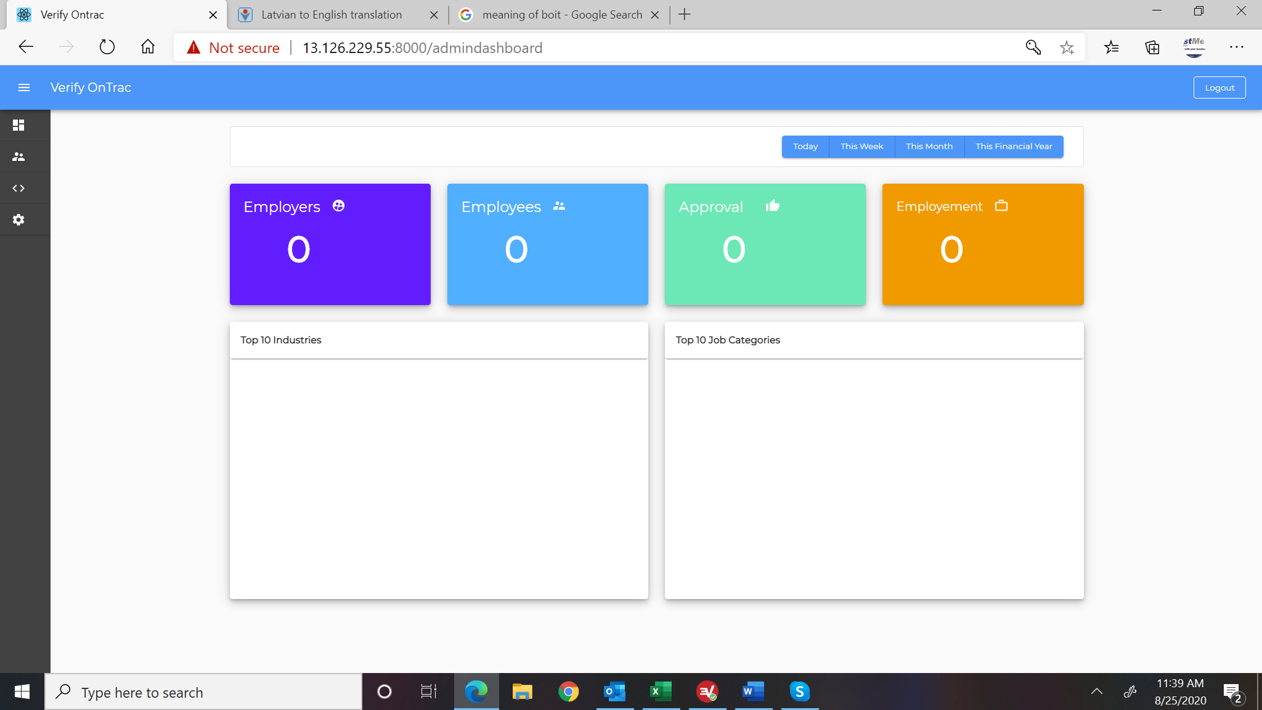

1. The menu should be in expanded form. The user can collapse it if needed
2. Add to dashboard Subscription Revenue -

* Add to the dashboard Verification Revenue-working

[Srikanth]: Completed

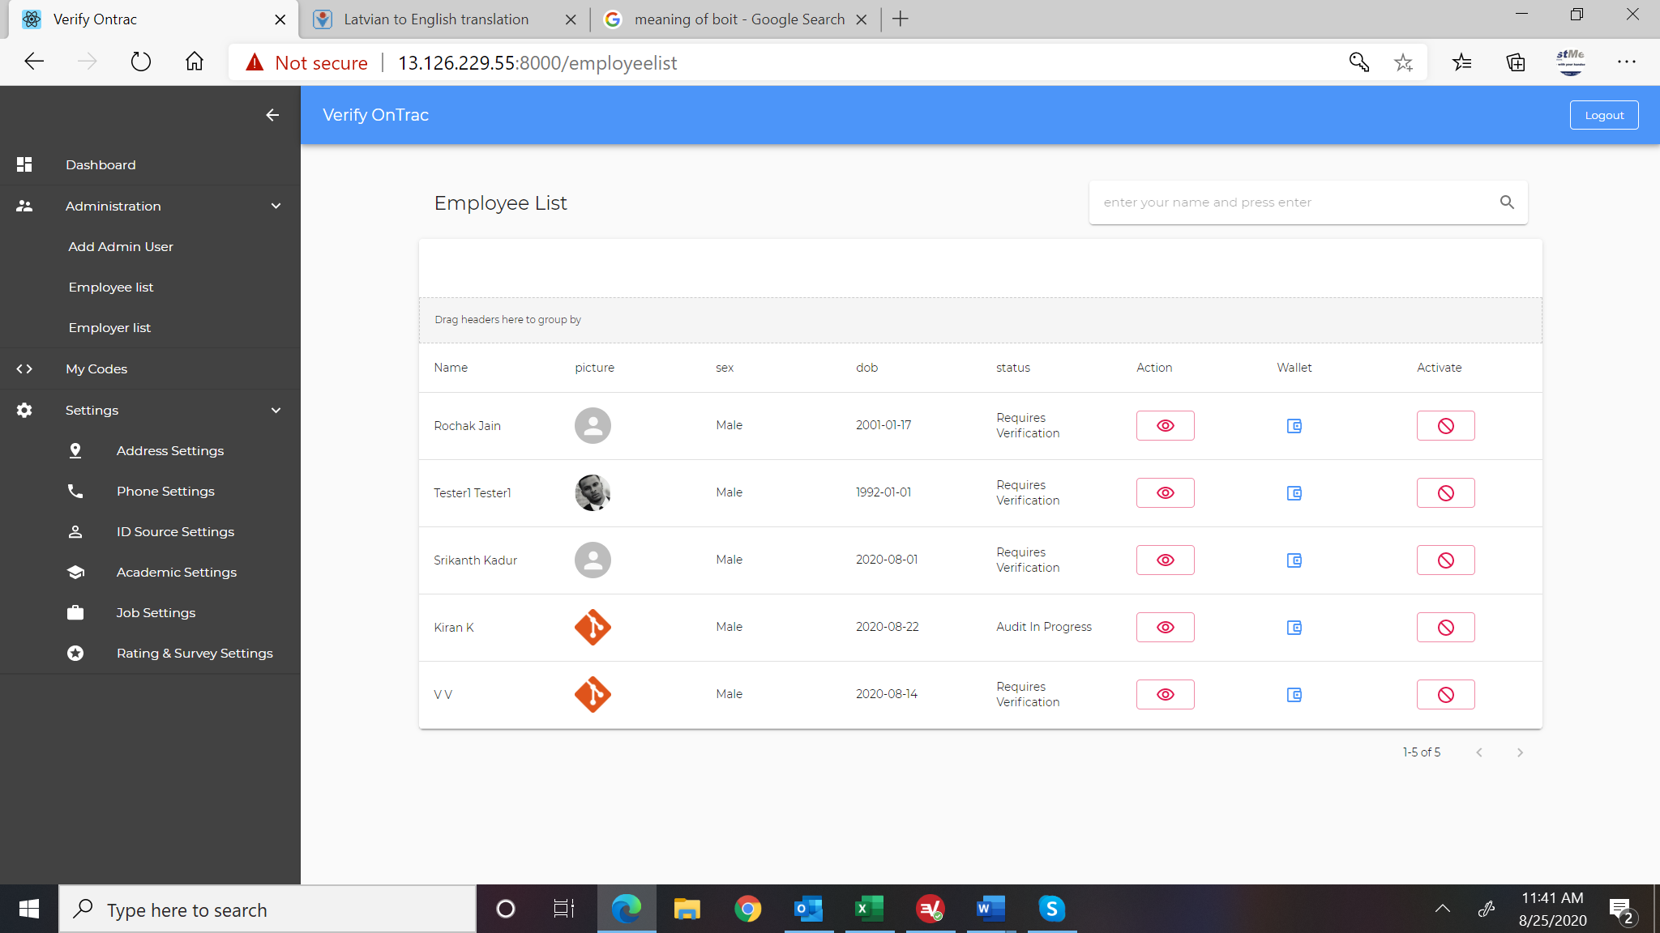

1. Modify table headers such that the fist letter is upper case. i.e picture changed to Picture and dob changed to DOB.
2. Add new columns Date to display the date employee signed up, add column for Phone#.-need both the fields in get employee list api Phone# and User account enrolled date

[Srikanth]: Completed

1. Change Action to View. When click on view, show the same data and in the same format as the default page for when employee logs in. add button or icon to click to close the page.(doubt)
2. When clicked on wallet list employee transaction and current balance. At the bottom of the list still show current information to charge/debit the account. When clicked on save, refresh the transaction list and remain on the page.(doubt and need a api)

[Srikanth]: Get account transaction API needs to be enabled for admin and given access to UI

[Srikanth]: Completed

1. Add button or icon to click on to close the page.
2. Change Activate to Enable/Disable and use the icon in blue color to indicate when it is enabled and use red icon (current one) to indicate when it is disabled. When click on, it will open a screen with dropdown Reason <Non Payment, Invalid Information, User Request>, Note, and save button. This information should be saved on the database. Add button/icon to click to close the screen.-need changes in backend api.

[Srikanth]: Add reason for activate / deactivate in accounts from backend.

[Srikanth]: Completed

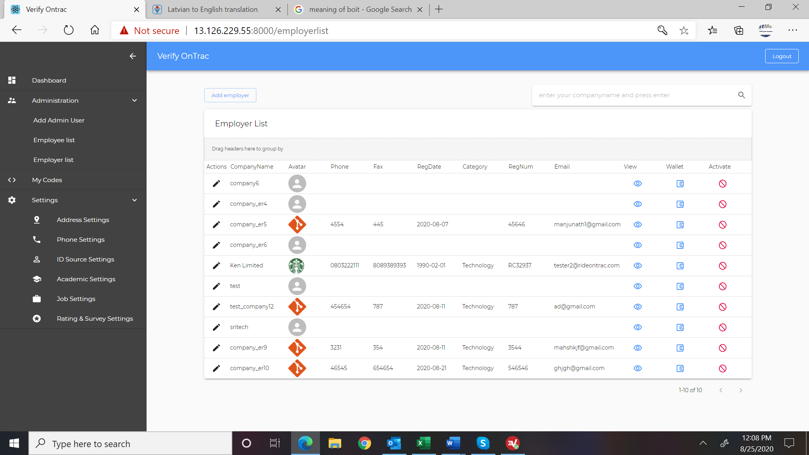

1. Remove Fax from the list. Add Date to show date of enrollment into the system. Add Contact and display the first & last of the contact entered during registration.-need backend change

[Srikanth]: Completed

1. Change Active to Enable/Disable. When clicked on should open screen to select reason and save. Add a button/icon on that screen for closing the screen.-need backend change

[Srikanth]: Completed [Same as Employee]

1. Add Subscription End Date to list of items displayed.-need backend change

[Srikanth]: Completed

1. When clicked on wallet list employers transaction and current balance. At the bottom of the list still show current information to charge/debit the account. When clicked on save, refresh the transaction list and remain on the page. Add a button/icon for closing this screen.(doubt) and change in api

[Srikanth]: Completed

1. Change Activate to Enable/Disable and use the icon in blue color to indicate when it is enabled and use red icon (current one) to indicate when it is disabled. When click on, it will open a screen with dropdown Reason <Non-Payment, Invalid Information, User Request>, Note, and save button. This information should be saved on the database. Add button/icon to click to close the screen

Srikanth]: Completed [Same as Employee]

1. Remove the icon and column for Action (for editing).
2. How do I see list of companies added by admin. Add a checkbox to “include Unregistered Companies”

[Srikanth]: Compelted “Added ‘is_admin_added’ flag in the employer list and you can showcase the list based on this flag.

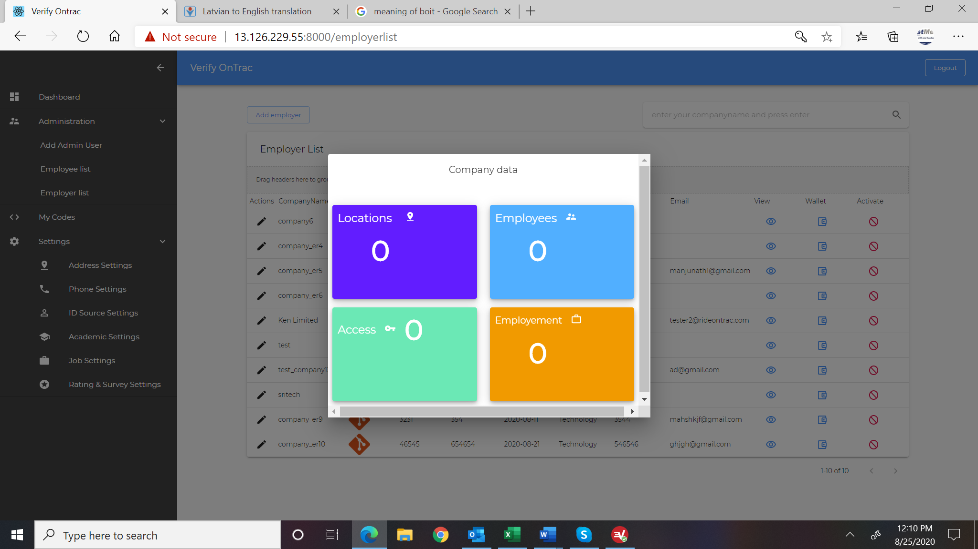

1. Expand this screen to be bigger and make it two rows of data to avoid the scroll bars. Add a button/icon for closing this screen.
2. Add filters for Today, This Week, This Month, This Financial Year-need api changes

[Srikanth]: added filters ‘today’,’week’,’month’,’year’ 🡺 <http://3.22.17.212:9000/getEmployerKpi?company=company_er5> 🡺 existing usage which is not affected

<http://3.22.17.212:9000/getEmployerKpi?company=company_er5&filter=today>

If “filger parameter is not provided it works as existing usage”

COMPELTED

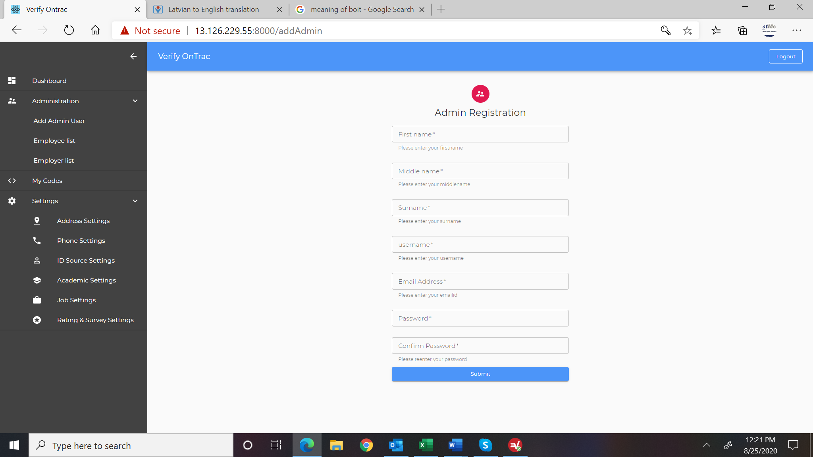

1. This should list existing user (first name, last name, date created, View Accounts, Enable/Disable. Clicking on View Accounts will show list of the account assigned to this user to manage with “Remove” button next to each record for removing that user from their list. Click on Enable/Disable to enable or disable the user.-need get api for adminusers and enable/disable api and view api and remove api
2. Add phone number to the list -need backend change

[Srikanth]: No change needed from backend, exising APIs can be used for listing all the accounts. I believe we need more clarification on this

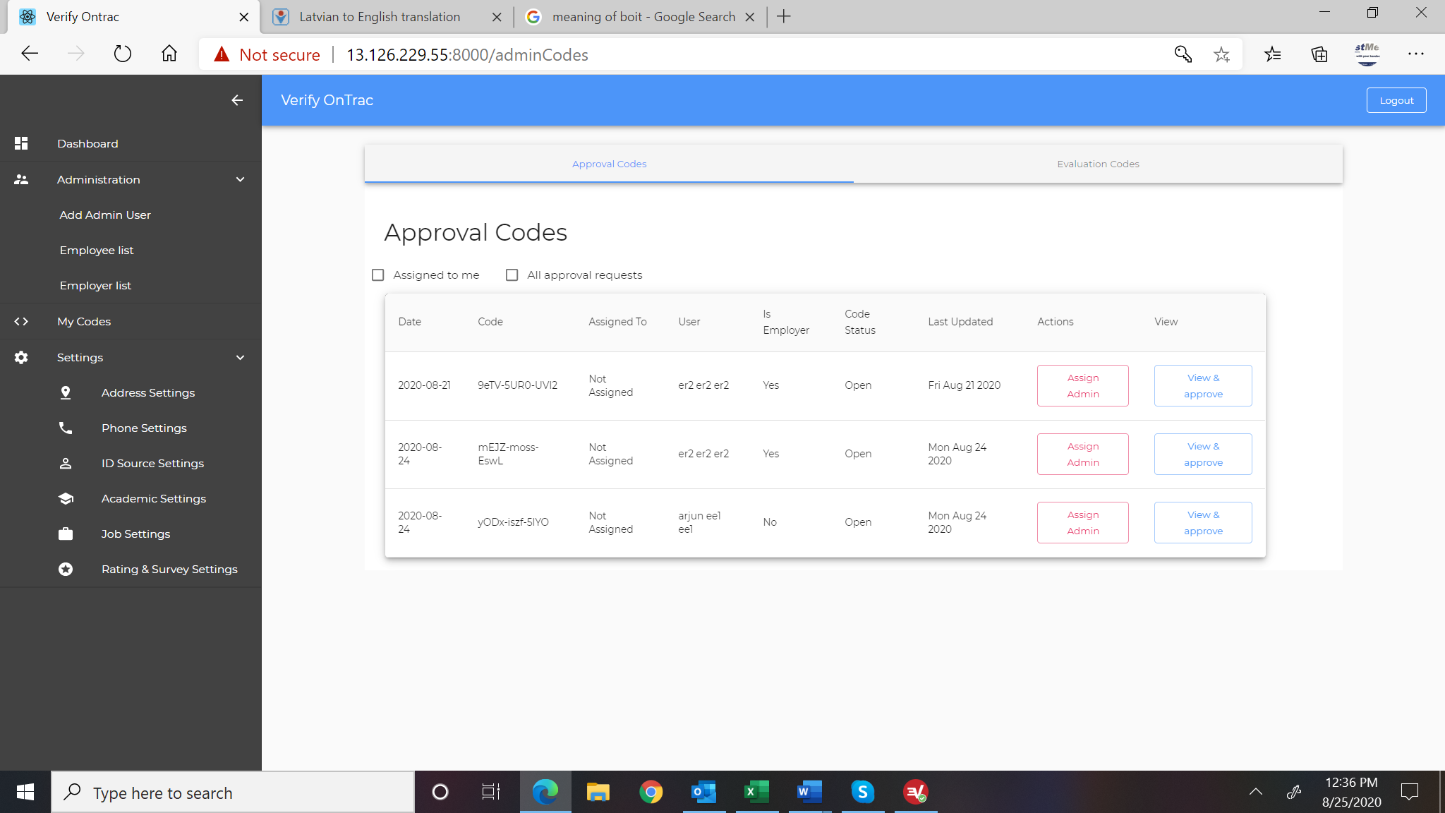

1. Change My Codes on the menu to Applications. Change Approval Codes to Enrollment Request. Change Evaluation Codes to “Verification Request.”
2. Sort the data such that the most recent records are on top
3. Change Assign Admin and View & Approve request from 2 lines to single line to reduce the size of icon and thereby reduce the height of the column.
4. Add Checkbox to view Rejected Enrollment. It should be next to the other two checkboxe-need api for this.

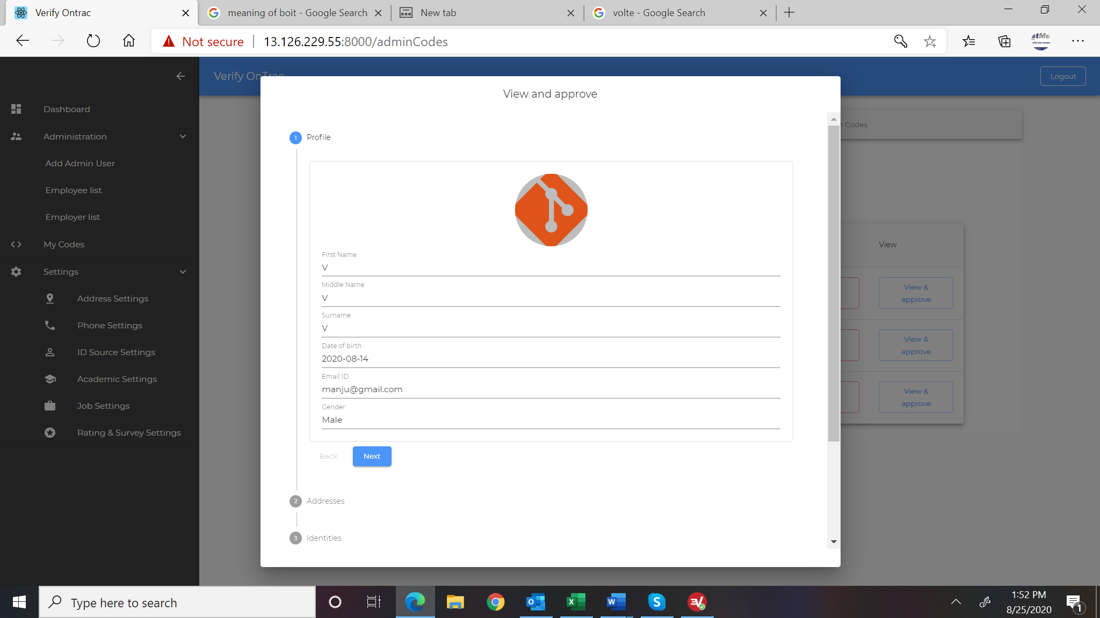

1. This should have the same format as the profile display for employee to allow admin to go through the records, pull up the images for id, etc(doubt)

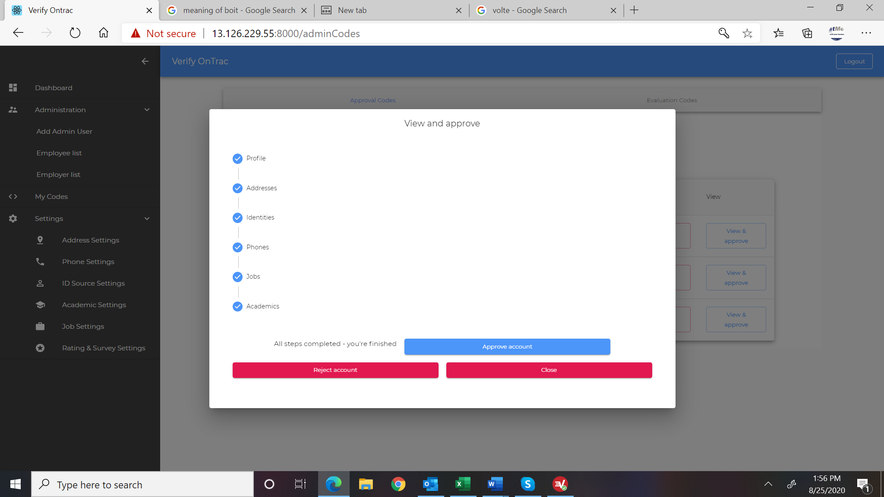

1. We need a 4 option which is to send information to employee on additional information needed before account can be approved. This page should be on the last tab of the profile #6 above or shown on top of the overall pages before the tabs are displayed.
2. For employer, add Field “Subscription End Date” and default the date to 1 month from current date.(doubt) and need backend change

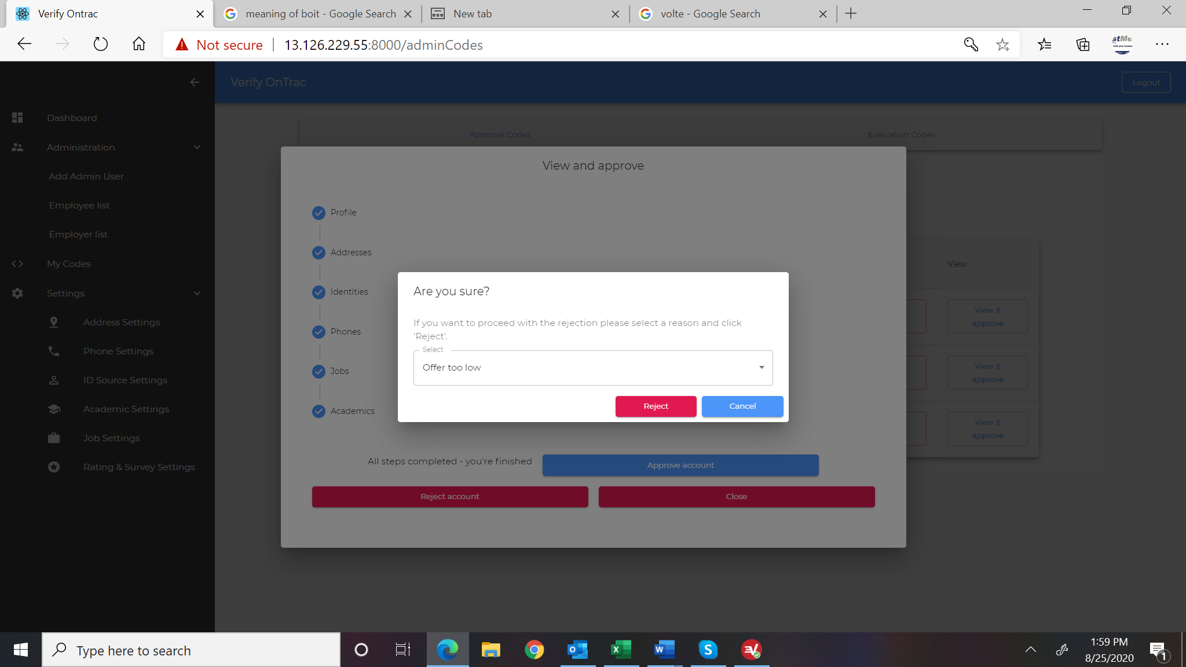

1. This is not working well. It returns me to the view and approve page without indicating I have successfully rejected the request. It should disable all button and leave only cancel or return to main page showing list.

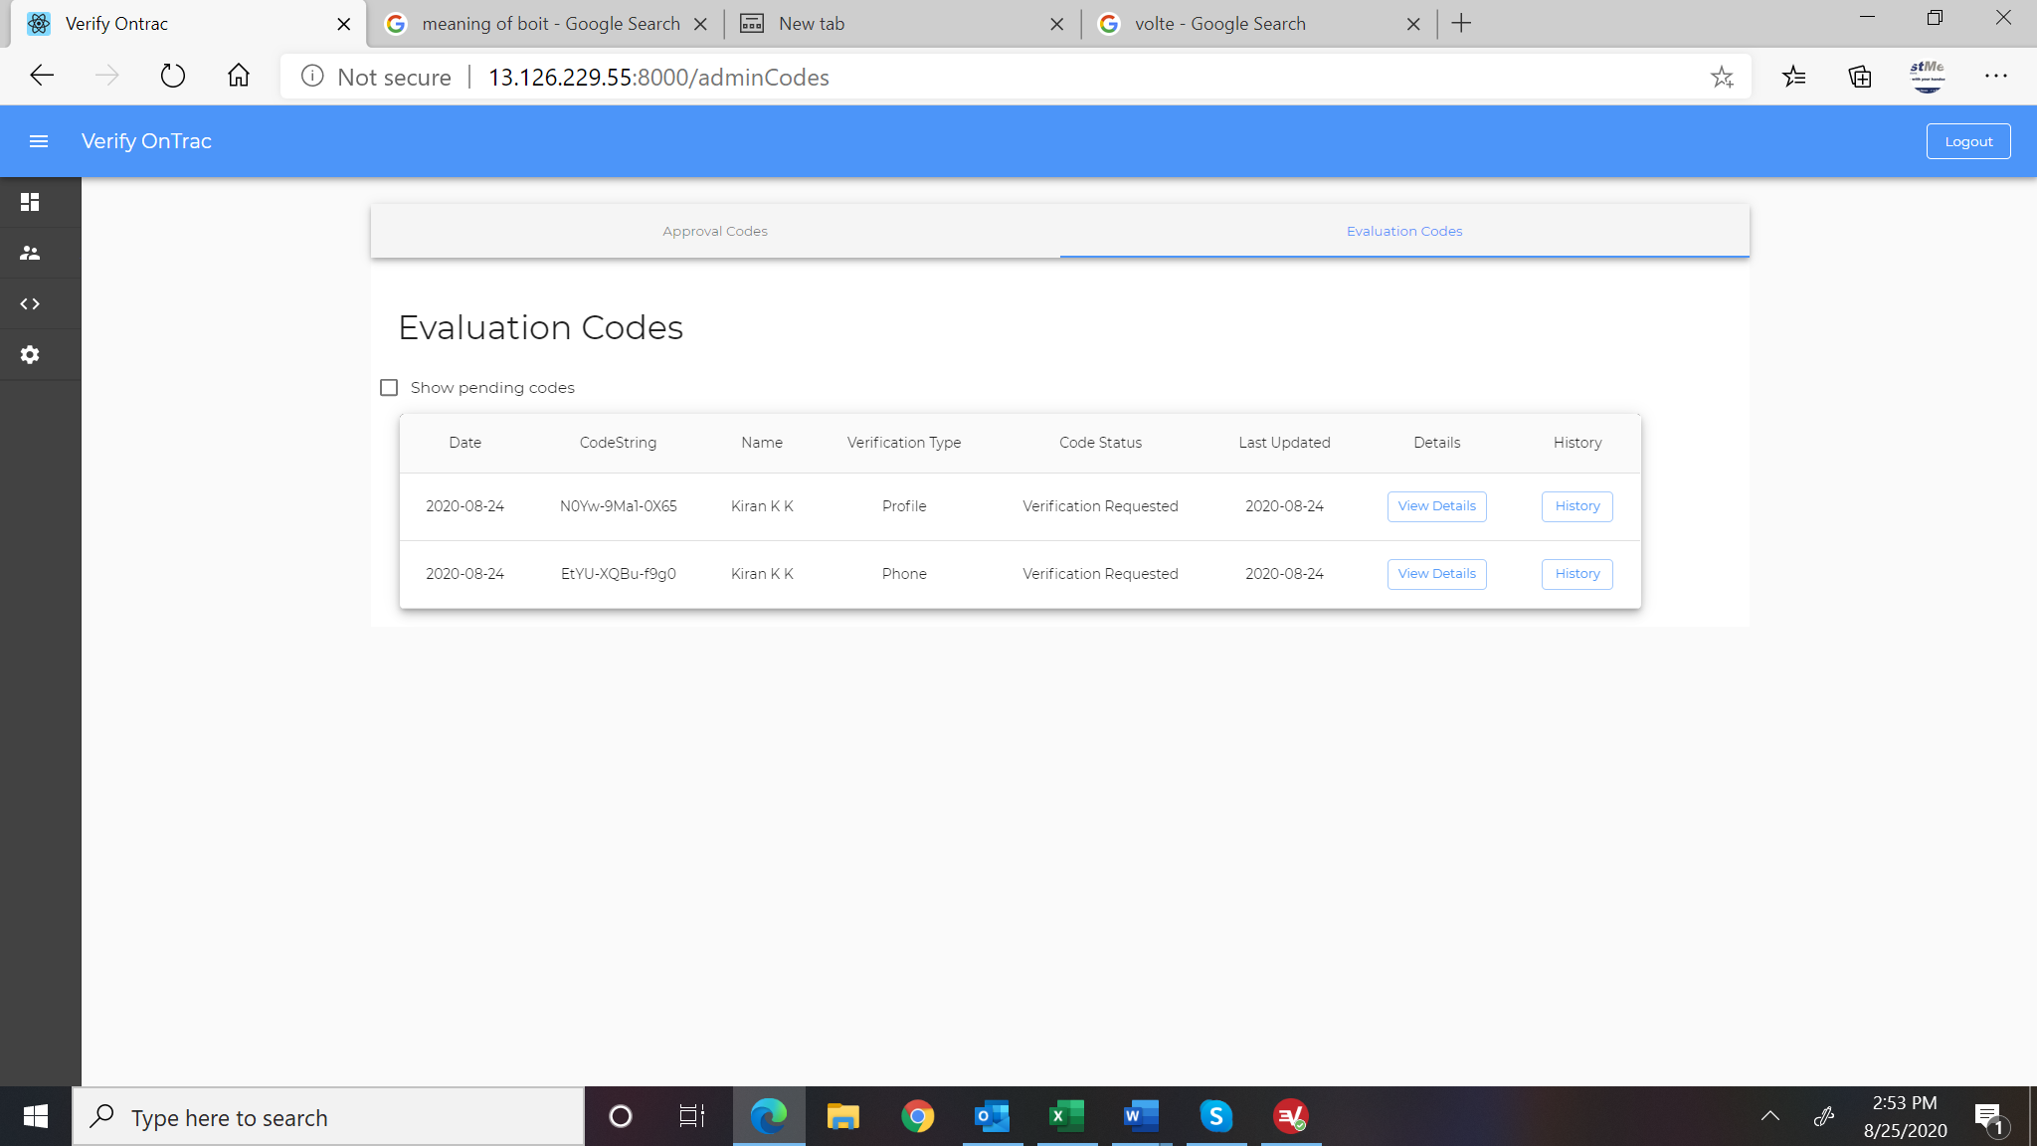

1. This does not refresh.

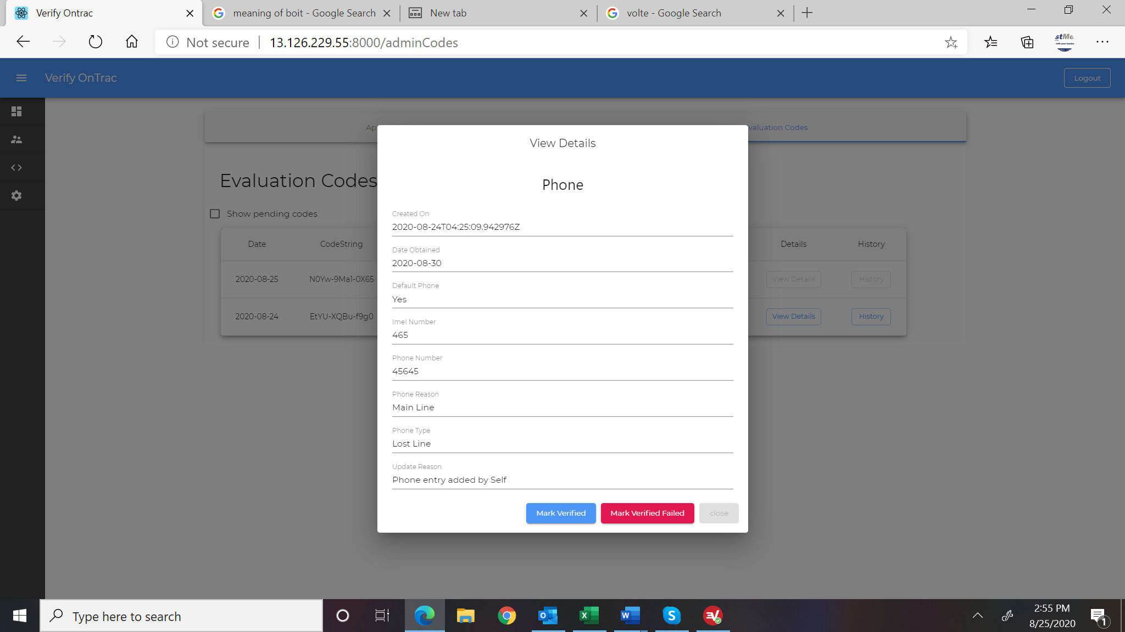

1. Enable close button at all times.

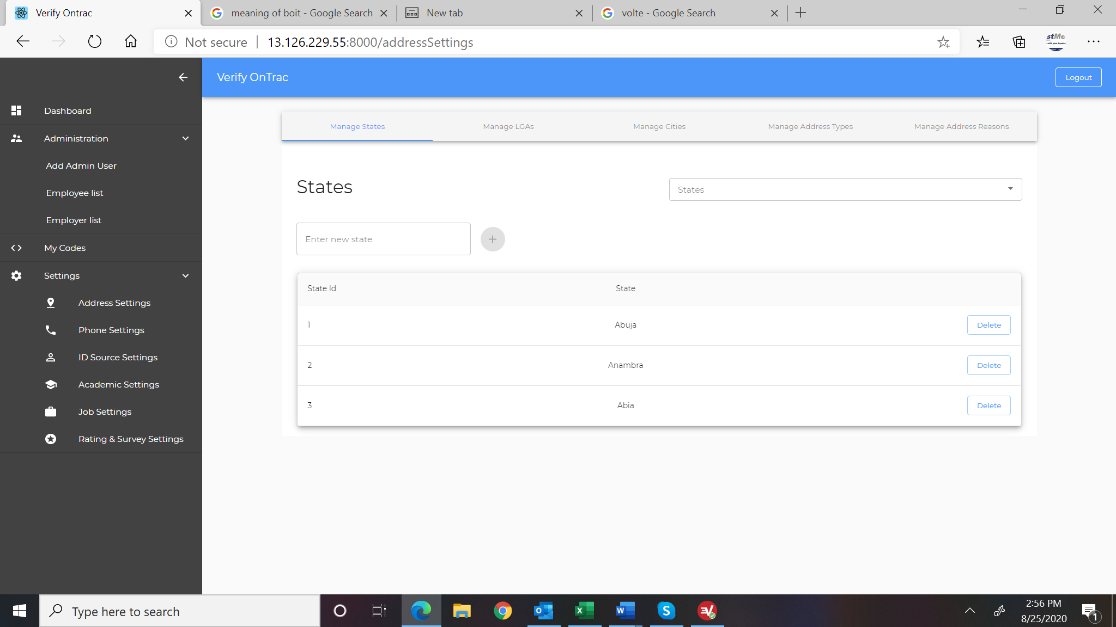

1. Preload data for state and local government and remove from this list. User can enter cities and select State and local government to attribute it to.(doubt)
2. Add a menu item called “Chargeable Items”
   1. This screen will list existing chargeable items with a button to add new. The list will show Type, Amount, Linked to, Description
   2. Add New will have the following fields
      1. Select Type dropdown with values Employee, Employer
      2. Amount which is input box to enter the amount to be charged
      3. Linked to which is dropdown with list for Employees as Address, Phone, Job, ID, Academics, and for employers it will have 1 – 5 Employees, 6 – 15 Employees, 16 – 50 Employees, Above 50 Employees
      4. Description which is input box up to 100 characters
   3. The items are tied to wallet items when deducting credits from the wallet.-new module completly

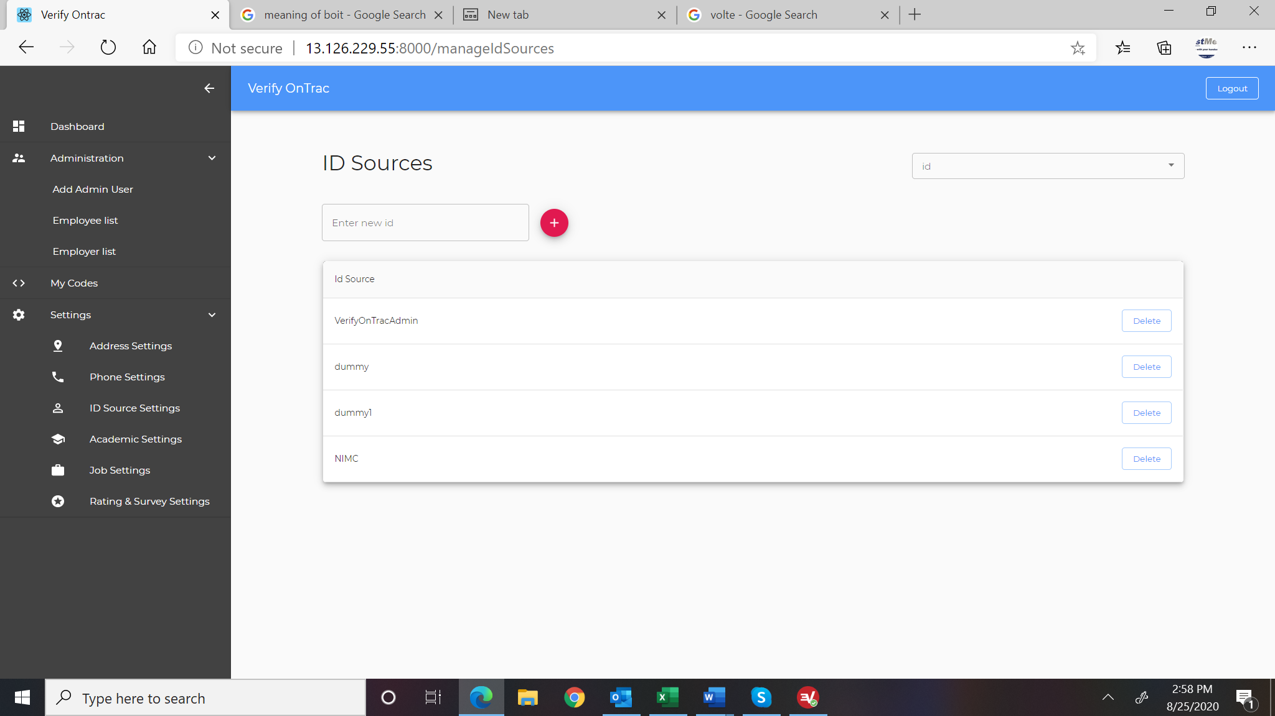

1. Modify this so that in addition to name, the following fields are enabled.
   1. Checkbox for “Is Issue Date Required”
   2. Checkbox for “Is Expiring Date Required”
   3. Checkbox for “Is Front View Picture Required”
   4. Checkbox for “Is Back View Picture Required”-requires api changes

Please note in Version 1.1 we will need to enforce these when employee is entering ID information.

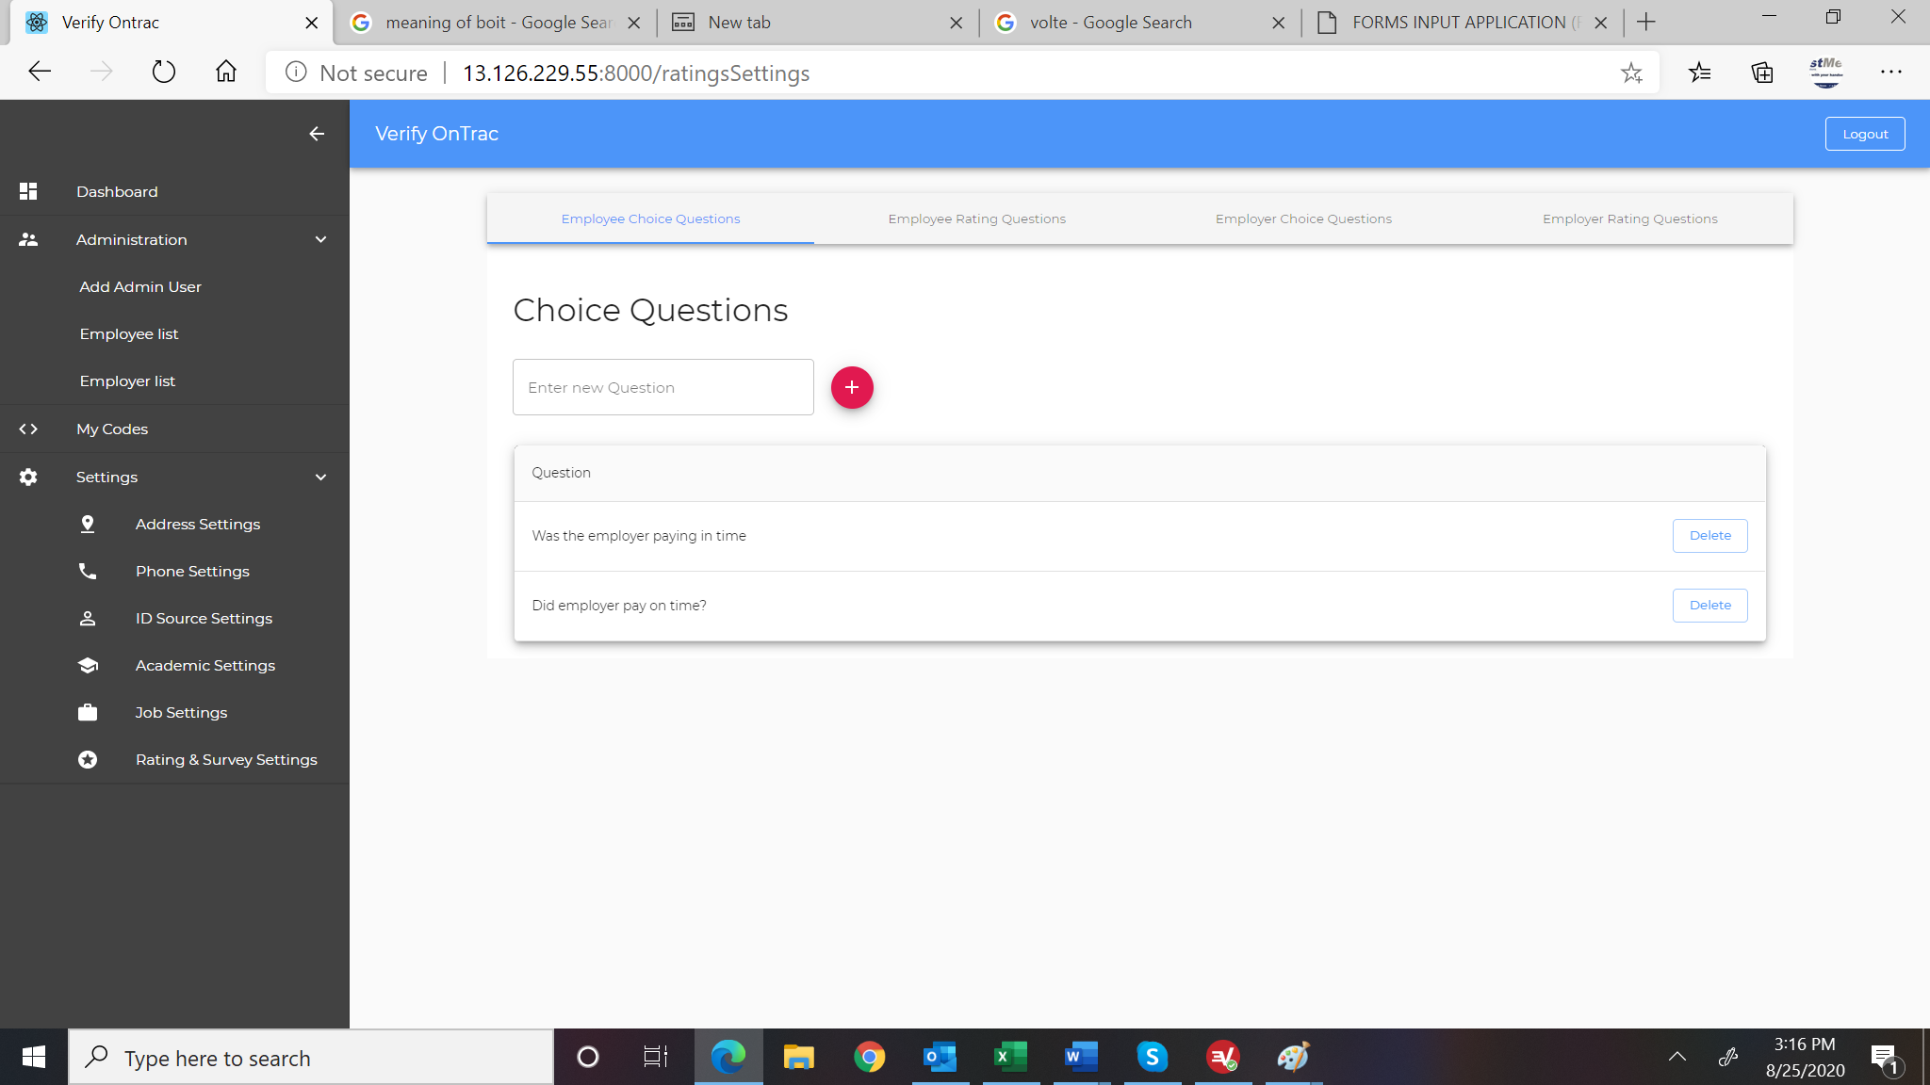

If this module changes then onboading and offboarding modules will change

1. This is not implemented per specification. It is a dynamic form entry that requires the three steps shown below .

Step 1 is to add a new question

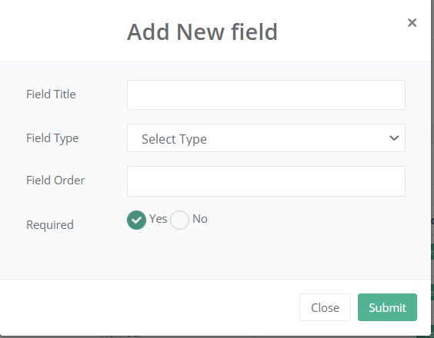

Step2 is to select the type of answer expected. If it is yes or no type or input box, etc

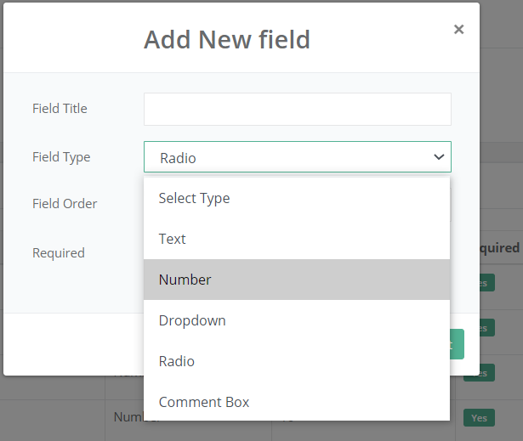

Step 3 is to enter the list of acceptable answers when it dropdown, option box, check box, etc

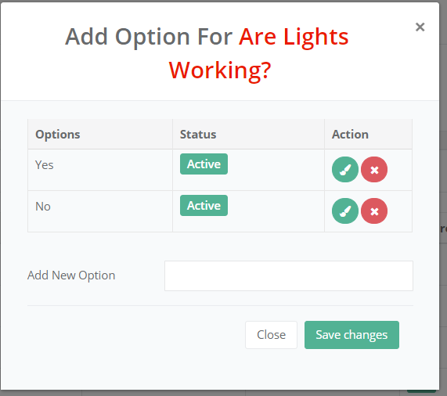

We can holdoff but this will be needed before launch.